3. ReactJS-HOL
Creating React App : npx create-react-app scorecalculatorapp

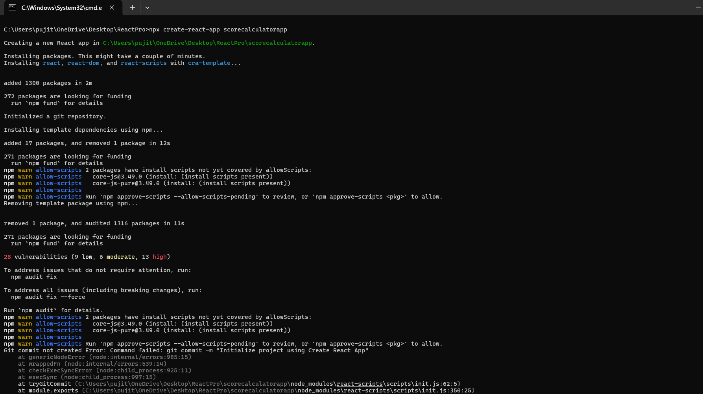
CalculateScore.js :
import React, { useState } from 'react';
import '../Stylesheets/mystyle.css'; // Importing custom styles

function CalculateScore() {
const [marks, setMarks] = useState({ math: '', science: '', english: '' });
const [result, setResult] = useState(null);

const handleChange = (e) => {
setMarks({ ...marks, [e.target.name]: Number(e.target.value) });
};

const handleCalculate = (e) => {
e.preventDefault();
const total = marks.math + marks.science + marks.english;
const percentage = ((total / 300) * 100).toFixed(2);
setResult({ total, percentage });
};

return (
<div className="score-card">
<h2>Score Calculator</h2>
<form onSubmit={handleCalculate}>
<div className="input-group">
<label>Mathematics:</label>
<input type="number" name="math" min="0" max="100" required onChange={handleChange} />
</div>
<div className="input-group">
<label>Science:</label>
<input type="number" name="science" min="0" max="100" required onChange={handleChange} />
</div>
<div className="input-group">
<label>English:</label>
<input type="number" name="english" min="0" max="100" required onChange={handleChange} />
</div>
<button type="submit" className="calc-btn">Calculate Score</button>
</form>

{result && (
<div className="result-display">
<h3>Total Marks: {result.total} / 300</h3>
<h3>Percentage: {result.percentage}%</h3>
</div>
)}
</div>
);
}
export default CalculateScore;

mystyle.css :
.score-card {
max-width: 400px;
margin: 40px auto;
padding: 25px;
border-radius: 10px;
box-shadow: 0 4px 15px rgba(0, 0, 0, 0.1);
background-color: #ffffff;
font-family: 'Segoe UI', Tahoma, Geneva, Verdana, sans-serif;
}
h2 {
text-align: center;
color: #333;
margin-bottom: 20px;
}
.input-group {
margin-bottom: 15px;
display: flex;
flex-direction: column;
}
.input-group label {
font-weight: 600;
margin-bottom: 5px;
color: #555;
}
.input-group input {
padding: 10px;
border: 1px solid #ccc;
border-radius: 5px;
font-size: 16px;
}

.calc-btn {
width: 100%;
padding: 12px;
background-color: #007bff;
color: white;
border: none;
border-radius: 5px;
font-size: 16px;
font-weight: bold;
cursor: pointer;
transition: background-color 0.2s ease;
}
.calc-btn:hover {
background-color: #0056b3;
}
.result-display {
margin-top: 20px;
padding: 15px;
background-color: #e2f0d9;
border-left: 5px solid #385723;
border-radius: 4px;
}
.result-display h3 {
margin: 5px 0;
color: #385723;
}

App.js :
import React from 'react';
import CalculateScore from './Components/CalculateScore';

function App() {
return (
<div style={{ backgroundColor: '#f8f9fa', minHeight: '100vh', padding: '20px' }}>
<h1 style={{ textAlign: 'center', color: '#444' }}>Student Performance Portal</h1>
<CalculateScore />
</div>
);
}
export default App;

Running on localhost 3000 :

